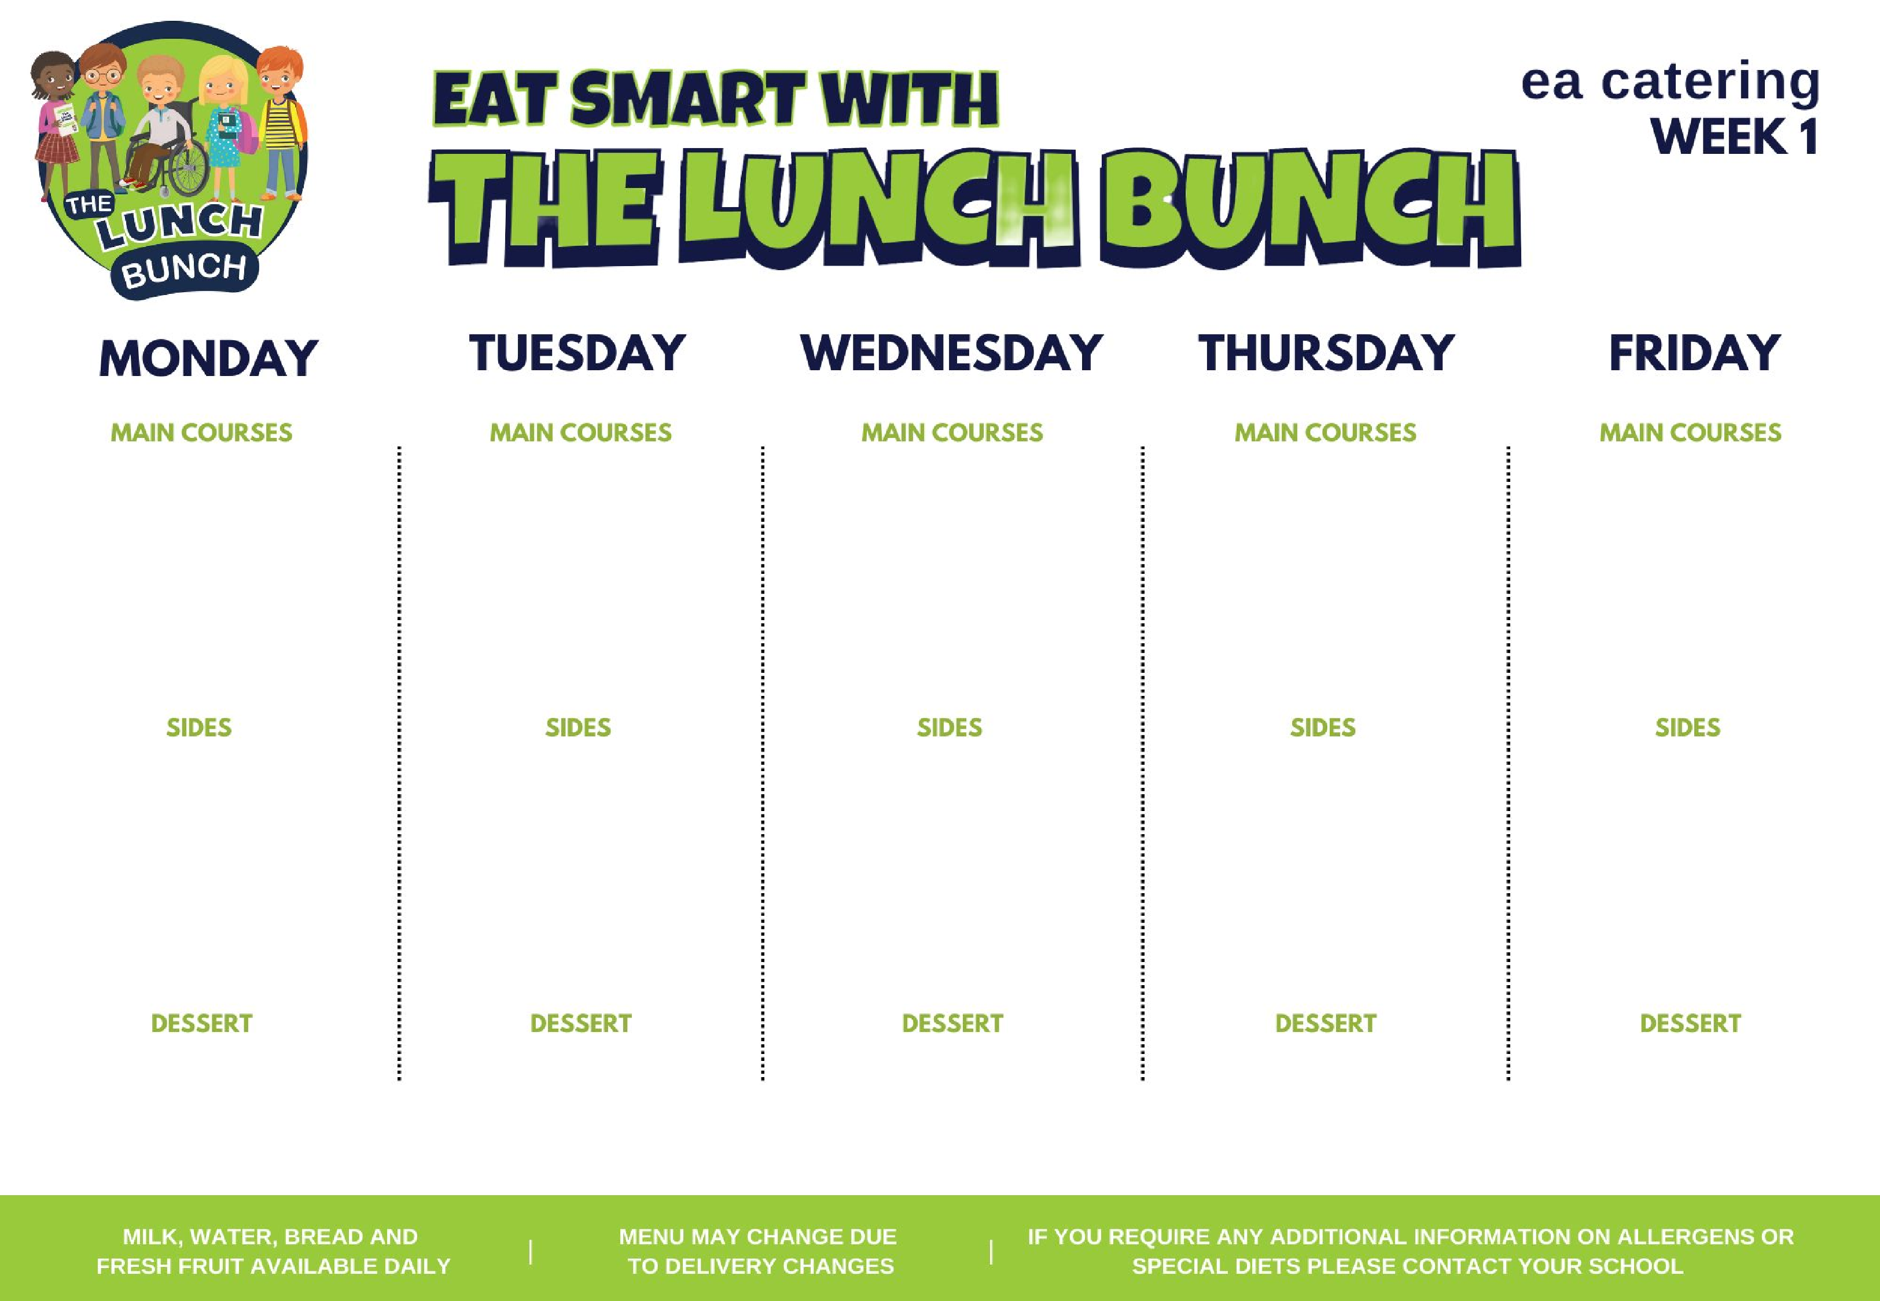

**Spaghetti Bolognaise**

**Or**

**Crispy Cod Fishcake**

**with Tomato Ketchup**

**Roast Chicken, Stuffing &**

**Rich Gravy**

**Or**

**Beef Olive**

**Classic Margherita Pizza**

**Or**

**Italian Chicken &**

**Tomato Pasta Bake &**

**Garlic Bread**

**Lunch Bunch Chicken**

**Curry & Naan Bread**

**Or**

**Chicken Panini &**

**Coleslaw**

**Hot Dog**

**Or**

**Chicken Wrap &**

**Sweet Chilli Sauce**

**Baton Carrots &**

**Baked Beans**

**Mashed Potato, Salad**

**Garden Peas & Coleslaw**

**Chipped Potato, Pasta**

**Steamed Broccoli &**

**Sweetcorn**

**Oven Roasted Potato**

**Wedges, Rice**

**Baton Carrots & Cabbage**

**Mashed Potato or roast**

**potato**

**Garden Peas & Spaghetti**

**Hoops**

**Chipped Potato, Pasta**

**Homemade Ginger**

**Biscuit & Custard**

**Banana Yoghurt Pot**

**Strawberry Jelly, Ice**

**Cream & Fruit**

**Chocolate Sponge &**

**Custard**

**Fresh Fruit & Yoghurt**

**18**

**September**

**16**

**October**

**13**

**November**

**December**

**11**

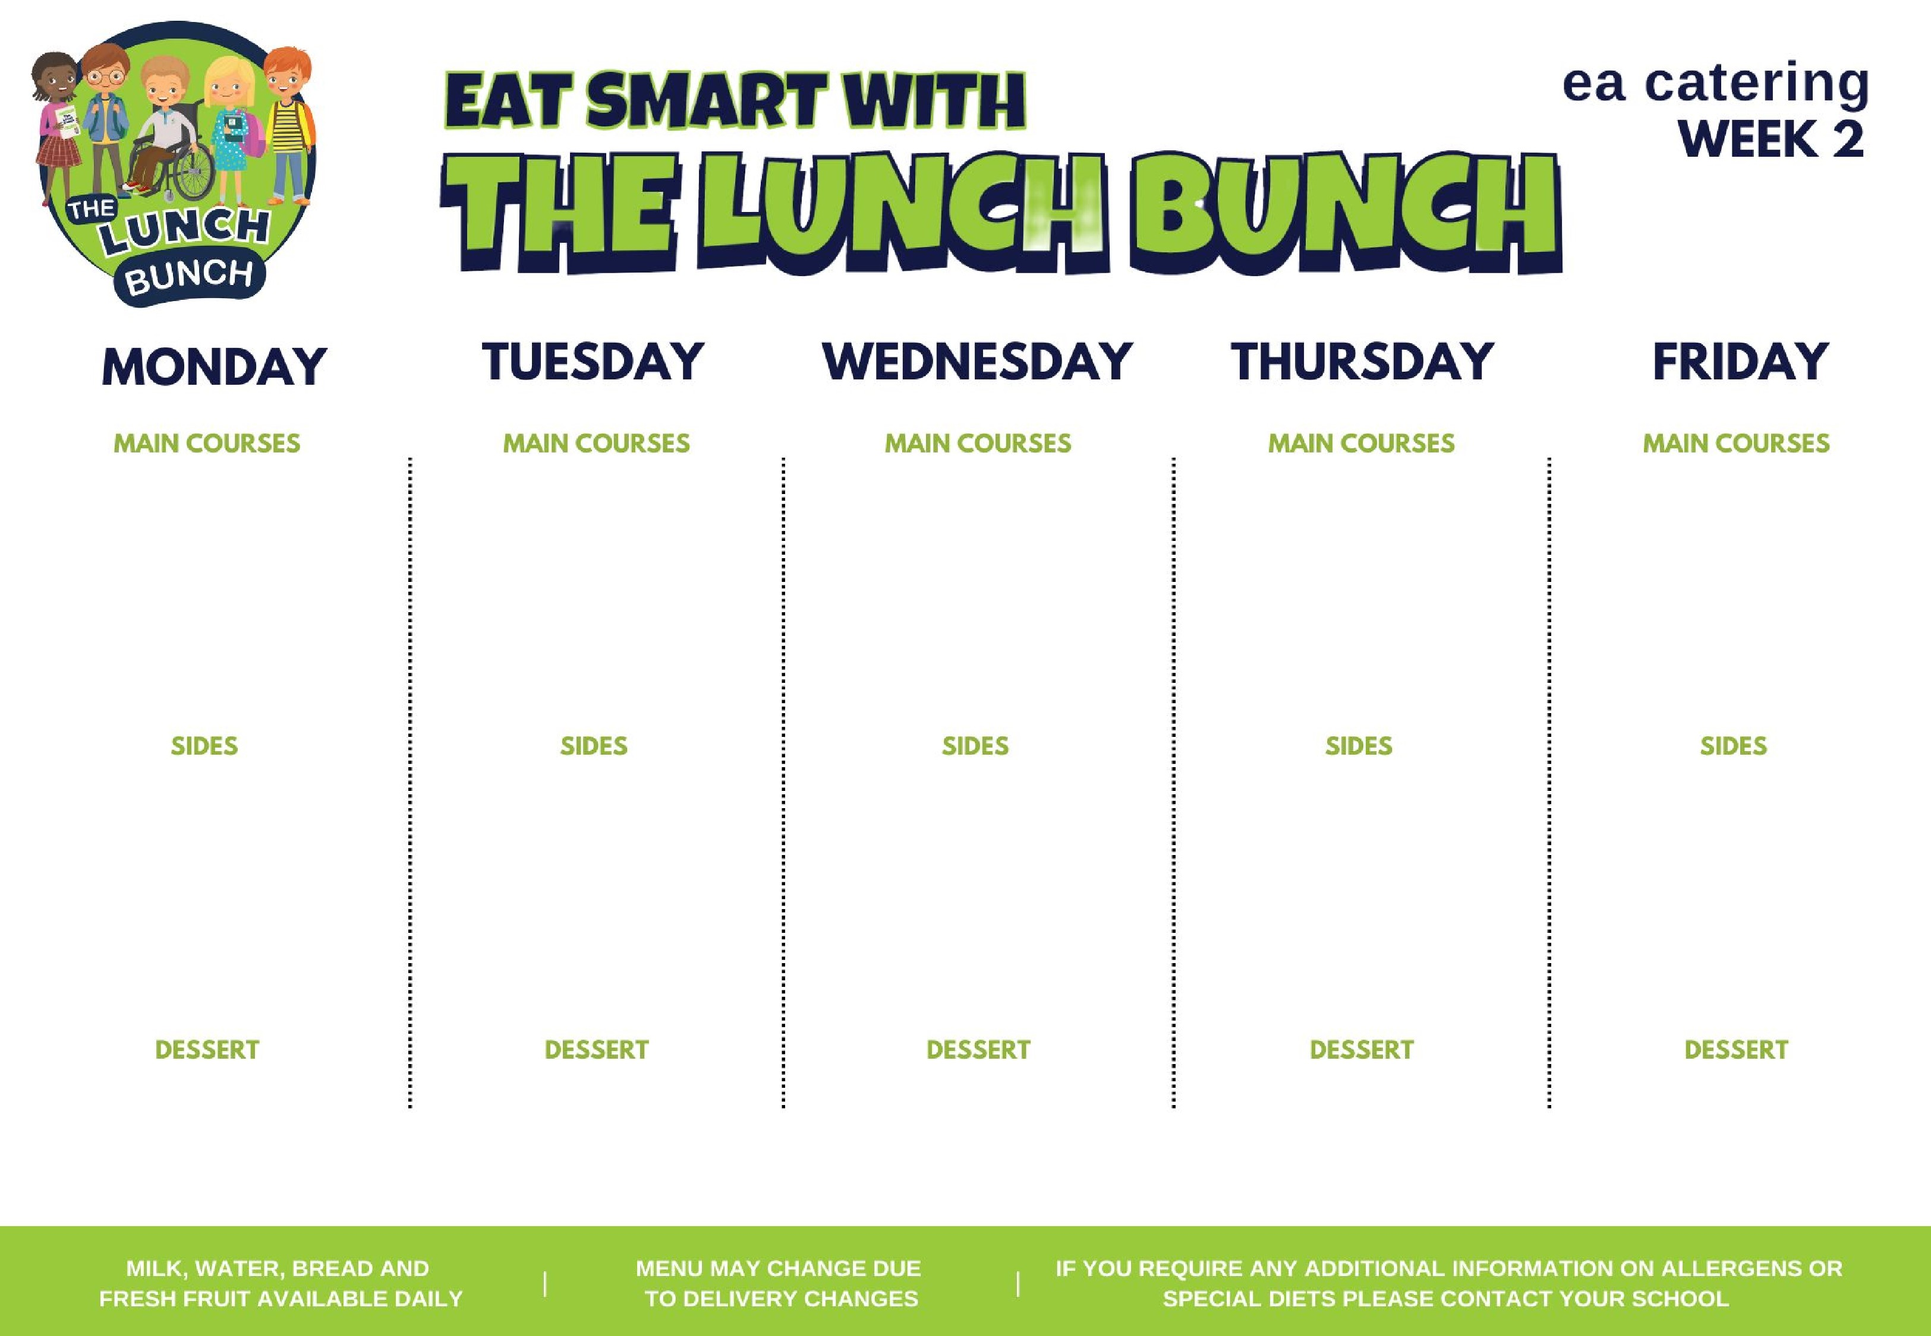

**Chicken Nuggets**

**Or**

**Homemade Lasagna**

**Roast Turkey, Stuffing &**

**Rich Gravy**

**Or**

**Salmon Fishcake**

**Spaghetti Bolognaise**

**Or**

**BBQ Chicken Pizza**

**Lunch Bunch Chicken**

**Curry & Naan Bread**

**Or**

**Golden Crumbed Fish**

**Fingers**

**Steak Burger &**

**Tomato Ketchup**

**Or**

**Chicken Crumble**

**Steamed Broccoli &**

**Garden Peas**

**Chipped Potato,**

**Mashed Potato**

**Sweetcorn & Baked**

**Beans**

**Diced Potatoes, Pasta,**

**Salad**

**Garden Peas**

**Rice, Salad, Mashed**

**Potato**

**Cauliflower & Baton**

**Carrots**

**Mashed Potato or Oven**

**Roast Potato**

**Sweetcorn & Salad**

**Or**

**Chipped Potato, Pasta**

**Ice Cream, Chocolate**

**Sauce & Sliced Pears**

**Rice Krispie Square &**

**Fruit**

**Fruit & frozen**

**strawberry mousse**

**Fruit Muffin Slab**

**Flakemeal Biscuit &**

**Fruit**

**August**

**28**

**September**

**25**

**October**

**23**

**20**

**November**

**December**

**18**



**Golden Crumbed Fish**

**Fingers**

**Or**

**Mighty Mac ‘n’ Cheese**

**with Garlic Bread Slice**

**Roast Chicken, Stuffing &**

**Rich Gravy**

**Or**

**Mexican Chilli with**

**Nachos**

**Beef Meatballs with**

**Italian Tomato & Basil**

**Sauce**

**Or**

**Margherita Pizza**

**Lunch Bunch Chicken**

**Curry & Naan Bread**

**Or**

**Bacon Slice**

**Tasty Pork Sausages**

**with Tomato Ketchup**

**or Gravy**

**Or**

**Chicken Panini &**

**Coleslaw**

**Baked Beans &**

**Broccoli & Coleslaw**

**Mashed Potatoes**

**Garden Peas & Salad**

**Oven Baked Potato**

**Wedges, Pasta**

**Mini Corn on the Cob**

**Steamed Rice, Chipped**

**Potatoes**

**Baton Carrots & Tossed**

**Salad**

**Mashed Potato or roast**

**potato**

**Sweetcorn & Spaghetti**

**Hoops**

**Chipped Potatoes &**

**Mashed Potatoes**

**Artic Roll with**

**Peaches**

**Strawberry Jelly &**

**Fruit**

**Shortbread, Milk**

**Shake & Fruit**

**Jam & Coconut**

**Sponge & Custard**

**Melon Wedge**

**September**

**04**

**October**

**02**

**30**

**October**

**27**

**November**



**Beef Bolognaise with**

**Garlic Bread**

**Roast of the Day, Stuffing**

**& Rich Gravy**

**Or**

**Stuffed Chicken**

**Golden Crumbed Fish**

**Fingers**

**Or**

**Tex-Mex Enchilada**

**Lunch Bunch Chicken**

**Curry & Naan Bread**

**Or**

**Steak Burger & Gravy**

**Oven Baked Chicken**

**Nuggets**

**Or**

**Admiral’s Ocean Pie**

**Garden Peas &**

**Cabbage**

**Oven Baked Potato**

**Wedges, Spaghetti**

**Mini Corn on the Cob &**

**Spaghetti Hoops or**

**Coleslaw**

**Chipped Potatoes, Pasta**

**Garden Beans &**

**Sweetcorn**

**Mashed Potato, Rice**

**Or**

**Stuffed Bacon**

**Roll/Bacon Slice**

**Cauliflower Cheese &**

**Baton Carrots**

**Mashed Potato**

**Garden Peas & Baked**

**Beans**

**Chipped Potatoes &**

**Baked Potato**

**Chocolate Cake &**

**Custard**

**Cornflake Biscuit &**

**Custard**

**Jelly & Mandarin**

**Oranges**

**Ice Cream with wafer**

**& Fruit**

**Homemade Ginger**

**Biscuit & Fruit**

**September**

**11**

**October**

**09**

**06**

**November**

**04**

**December**