Handling Complaints in St. John The Baptist Primary School

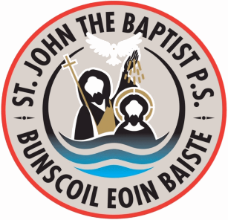
INFORMAL - Stage 1 -
Complaint made to appropriate member of staff (verbally)
Class Teacher
Key Stage Coordinator
Vice Principal – Mrs Coleman

Discuss the issues
Implement any agreements
No further action

INFORMAL - Stage 2 -
Complaint made to Principal (verbally)
Mr Mc Comb

Schedule meeting
Discuss the issues
Implement any agreements
No further action

FORMAL - Stage 3 -
Formal written complaint made to
Mr Mc Comb

Acknowledge receipt (within 10 working days)
Investigate the complaint
Implement any agreements / changes
Confirm outcomes in writing (within 20 Working days)
No further action

FORMAL - Stage 4 -
Formal written complaint made to Chairperson of Governors and referred to Governors’ Sub-Committee
Mr David Shortt

Acknowledge Receipt (within 10 Working days)
Investigate the issues / meet with complainant
Implement any agreements / changes
Confirm outcomes in writing (within 25 working days)
No further action

APPEALS PROCESS
Written request to have case heard by appeals committee of Board of Governors
Acknowledge Receipt (10 Working days)
Meet with complainant (30 Working days)
Consider the issues
Implement any agreements / changes
Confirm outcomes in writing (by the 40th working day)

If following Stage Five you remain dissatisfied with the outcome of your complaint, you can refer the matter to the Office of the Northern Ireland Public Services Ombudsman (NIPSO).
Telephone: 02890 233821

